API programming is not real programming.

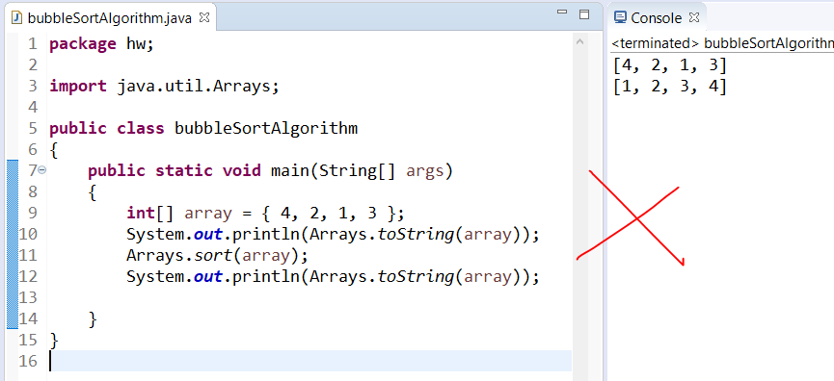

Without Abstraction(using functions to store sub logic); its mentally hard for me to understand and retain the coding logic for any algorithms.

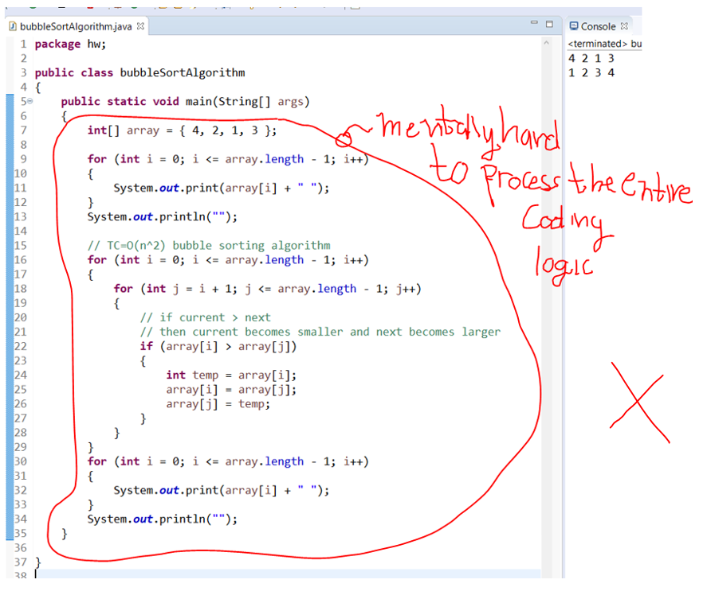

Using Abstraction(using functions to store sub logic for printing array, swapping elements, nested for loop); its mentally easier for me to understand and retain the coding logic for any algorithms.

